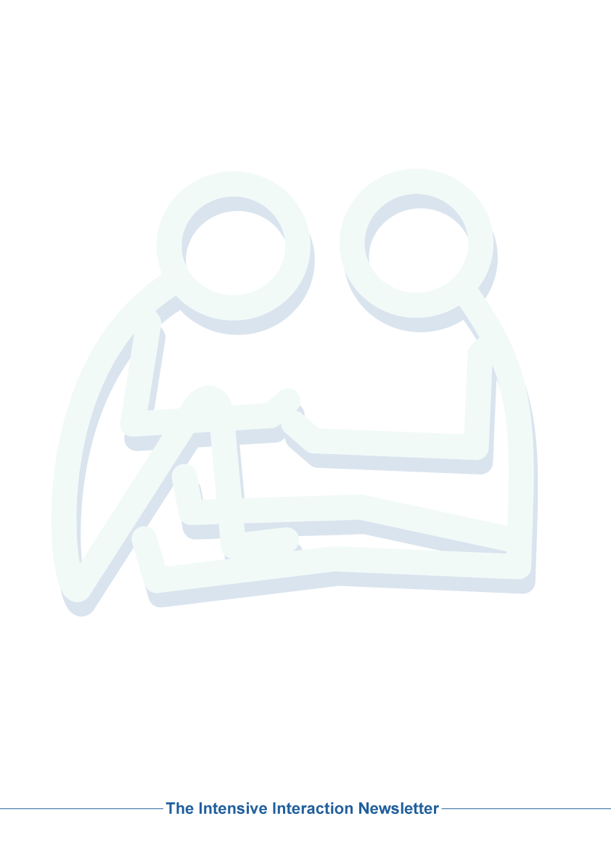

***Details of your***

***Intensive Interaction Week***

***event should go here.***

Once all your necessary event details have been included this document should be:

1. saved as a pdf file and electronically distributed , or
2. printed and posted out/displayed somewhere prominent.

Please also notify Graham Firth (at [**graham.firth@nhs.net**](mailto:graham.firth@nhs.net)) of your event, as he will compile a brochure of all events alerted to him. This brochure will then be distributed widely and advertised via official Intensive Interaction Institute channels.

**‘Intensive Interaction Week’ 2016!**

The International 'Intensive Interaction Week' is:

**Monday 10th -** **Sunday 16th October 2016**.

This will be a week when people from across the world can collectively do something ***'a bit extra'*** to promote Intensive Interaction.

- hosting a special networking event  
- doing an I.I. Café or Coffee Morning   
- posting special I.I. Blogs or videos   
- writing letters to different media  
- showing I.I. video at a staff meeting  
- doing some kind of *'Intensive Interaction Gathering*' or *'Flash Mob'*   
- or anything else that might positively raise the profile of the approach.

We would like to publicise these events to spread the I.I. word.

To include a notice of your event in this Intensive Interaction Brochure please email details of your event to Graham Firth at: [graham.firth@nhs.net](mailto:graham.firth@nhs.net)

***The Intensive Interaction Institute***

**International**

**Intensive Interaction Week**

**2017**

**Monday 9th - Sunday 15th October 2017**

After a very successful International effort in 2016, 'Intensive Interaction Week'is back again in 2017. This is a week when people from across the world collectively do something 'a bit extra' to promote Intensive Interaction.

Below are details of a local event that may be of interest to you!