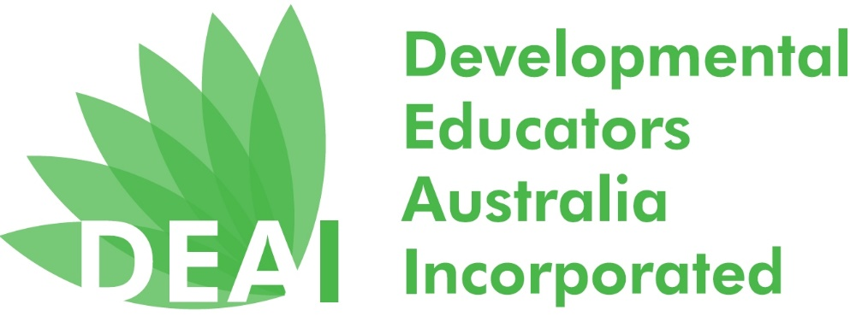

Order form for National Developmental Educators’ Week 19-23 November 2018
To help you celebrate National Developmental Educators’ Week a promotional pack is available from the DEAI for free.
A promotional pack contains:
- 2 Keyrings
- 2 Pens
- 2 Stickers
- 2 Magnets
- 2 DEAI postcards
- 4 Green and White Balloons
You can order 1 promotional pack per person (until stocks last).
Collection Method (Please only complete the preferred option)
I will collect the pack at the DEAI AGM on Monday 19th November.
Name:
Email:
Phone No.
Please order by Friday 7th November
Or
I am unable to collect the pack but nominate the person below to collect at the DEAI AGM on Monday 19th November, on my behalf.
Name:
Email:
Phone No.
Name of person collecting on my behalf:
Please order by Friday 7th November
Or
Please post the pack to the details below:
Name:
Agency:
Address:
Email:
Phone No.
Please order by Friday 7th November

Please return this form to contact@deai.com.au.

