SACID Reference Group
SACID is setting up a reference group
The SACID Reference Group:
- is for people with intellectual disability
- will give people with intellectual disability more say at SACID
- will help SACID to know what is important to people with intellectual disability

You will be paid for being in the reference group if you are chosen to be part of it
You do not have to live in Adelaide to join the reference group
SACID will decide who is in the reference group
In the SACID Reference Group
You will meet once a month
You will learn about:
- being on a committee
- running meetings
- speaking up
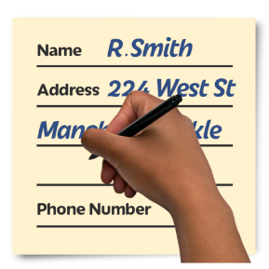
If you want to be in the SACID Reference Group please fill out the form on the next page

If you want to know more you can contact SACID:
8352 4416 admin@sacid.org.au

SACID Reference Group – Application Form
This form is for people with intellectual disability who would like to join the SACID Reference Group
What is your name?

What is your date of birth?

How do you want SACID to contact you?

Email Address:
Number:

Post address:

Do you have an intellectual disability? □ Yes □ No
Do you have other disabilities? □ Yes □ No

Please write what your other disabilities are:

Could you come to a monthly meeting? □ Yes □ No
Please write here why you are interested in joining the SACID Reference Group. You can add more paper if you want to write more:

When you have finished this form:
Attach it in an email: admin@sacid.org.au
Or
Post it to:
South Australian Council on Intellectual Disability, 302 South Road, Hilton SA 5033

What happens now?
SACID staff might ask you to meet them for an interview.
SACID staff will decide who will be in the reference group.
Not everyone that sends back this application form will be chosen for the SACID Reference Group.
If you are not chosen for the SACID Reference Group:
- You can still be a SACID member
- You can ask us why we did not choose you

