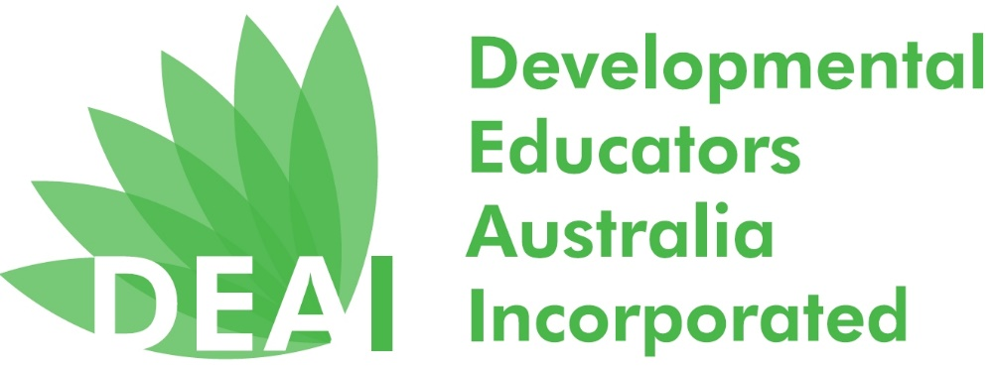

Order form for National Developmental Educators’ Week 11 - 15 Nov 2019
To help you celebrate National Developmental Educators’ Week a promotional pack is available from the DEAI for free.
A promotional pack contains:
- 1 pen
- 1 keyring
- 1 DE Sticker
- 1 I love DEs Sticker
- 2 postcards
- 2 brochures
- 1 fridge magnet
- 4 green and white balloons
Until stock lasts, 1 promotional pack per person. Please only complete the preferred collection option below and order by Wednesday 23rd of October.
I will collect the pack at the DEAI AGM on Thursday 7th November.
Name:
Email:
Phone No.

I am unable to collect the pack, but nominate the person below to collect at the DEAI AGM on Thursday 7th November, on my behalf.
Name:
Email:
Phone No.
Name of person collecting on my behalf:

I am unable to collect the pack as I live in the country or interstate and need the promotional pack posted to the nominated address.
Name:
Email:
Phone No.
Address:
Please return this form to contact@deai.com.au.

