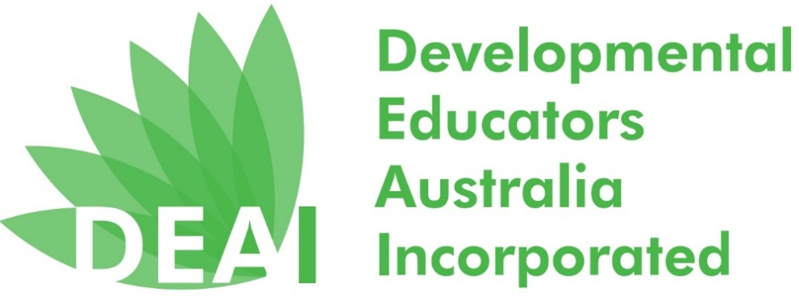

Order form for National Developmental Educators Week 23 - 27 Nov 2020
To help you celebrate National Developmental Educators’ Week a promotional pack is available from the DEAI for free.
A promotional pack contains:
- pen
- keyring
- DE Stickers
- postcard
- brochure
- fridge magnet
- green and white balloons
Until stock lasts, 1 promotional pack per person. Please only complete the preferred collection option below and order by Friday 13th of November.
I will collect the pack at the DEAI AGM on Monday 23rd November.
Name:
Email:
Phone No.

I am unable to collect the pack, but nominate the person below to collect at the DEAI AGM on Monday 23rd November, on my behalf.
Name:
Email:
Phone No.
Name of person collecting on my behalf:

I am unable to collect the pack as I live in the country or interstate and need the promotional pack posted to the nominated address.
Name:
Email:
Phone No.
Address:
Please return this form to contact@deai.com.au.

